AMRITA VIDYLAYAM CHENNAI, NESAPAKKAM
PA 1 MATHEMATICS
CLASS : XII MARKS :20 DURATION: 45 MIN
1 | 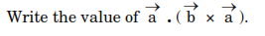 | 1
2 | 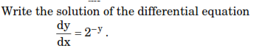 | 1
3 | 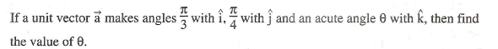 | 2
4 | 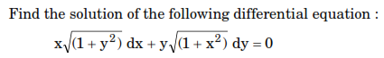 | 2
5 |  | 4
6 | 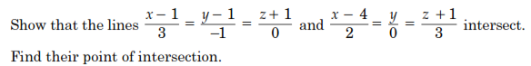 | 4
7 | 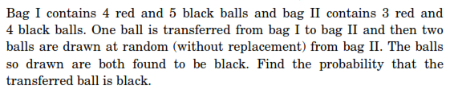 | 6

